Semester 3 - 2024
COMM2861 - Game Specialisation 1
Assignment 3: Specialisation Techniques Portfolio: Game Narrative Design

THE PEAK BEYOND

A Breezy 10-minute Experience by White Noise Group

s4023701 - Cao Uyen Thao
s3975580 - Bui Truong Thinh
s4022894 - Nguyen Pham Thu Linh
s4021265 - Nguyen Ngoc Tu Quyen

TABLE OF CONTENTS

LORE MODIFICATION 2
10-MINUTE GAMEPLAY 3
OVERVIEW 3
DESCRIPTION 3
SEQUEL 9
CHARACTER’S MOTIVATION 10
INFLUENCE OF THE STORY ON PLAYERS 11
REFERENCE LIST 12

LORE MODIFICATION
The morality decline after the encounter with the Spirit of the Dead is no longer a fixed event as presented in A2 since players will have a choice whether to keep or return the axes to the deceased mountaineer. If they keep the axes, their morality will drop and can not be restored to its default state. Ending 1 can only be met if players do not loot anything throughout their gameplay.

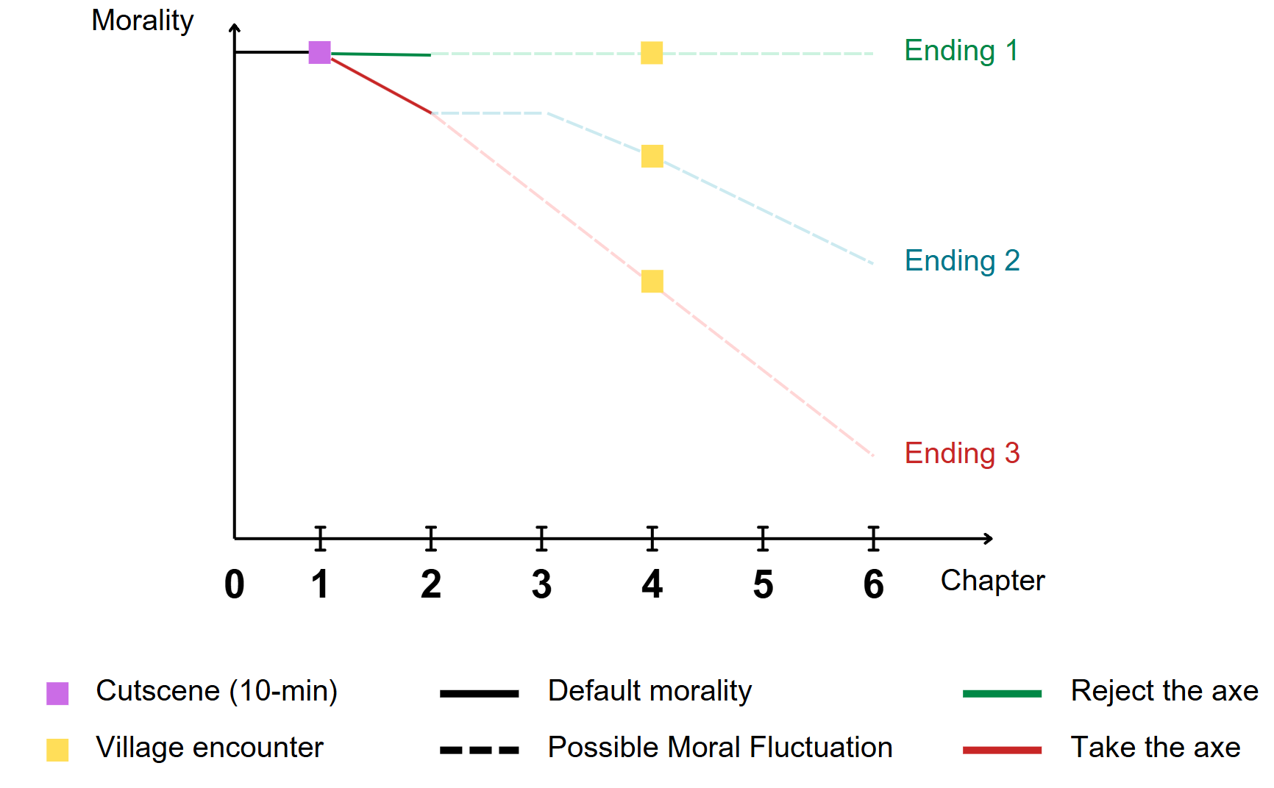

Figure 1: Modified moral fluctuation chart, created by the author in Canva

10-MINUTE GAMEPLAY

OVERVIEW

The 10-minute sequence takes place at the end of Chapter 1 when you - as the player - must encounter moral decisions after undergoing an unfortunate event. Here is what you will have known beforehand:
- Elisabeth’s Legacy: You will understand how your wife’s passing and her dream have fueled your determination to take on Mount Glaxierra.
- Climbing Basics: You will be briefed on the must-know rules of climbing, like avoiding nighttime climbs and the importance of bringing an oxygen tank.
- Mount Glaxierra’s Reputation: From the word of mouth of other climbers, you will learn about the mountain’s brutal climate and dangerous terrain, setting the tone for the tough journey ahead.

DESCRIPTION
Note: [Grey italic phrase in square brackets] stands for integrated in-game mechanics.

It is late afternoon, the sun is setting behind the mountains in the distance. The air is noticeably colder than it was earlier in the day. Soon, once night falls, the entire Mount Glaxierra would be shrouded in darkness. Since the temperature can reduce to -20°C or even lower, finding a place to set up a camp to rest before the Sun settles is essential.

Since noon, you have trekked through the nearby area to search for one but it seems you have not found any. As you proceed further, you are stopped by an ice slope. This is a steep slope, which is almost vertical and covered with thick ice. The constant breeze and biting winds that blow through only add to the slope’s harshness. The surrounding terrain is rugged, with scattered rocks, ice, and deep cracks in the ground. Looking around, you realize that it is impossible to continue from here unless you climb up this slope. Even though the climb is undeniably risky, you still have to do so due to the lack of a safe shelter.

You face the ice slope, pull out the two ice axes from your backpack, and hold them tightly. Wearing a look of determination, you swing the first axe and plant the pick firmly in the ice. With the second axe, you secure another hold at a higher position. After that, you lift your right leg off the ground, equipped with a boot and crampon, and kick the crampon spikes into the ice. You do the same thing for your left leg as you shift your body weight on the sharp points of your crampons for good balance. Having your foot and axe positions secured, you continue swinging the axe to ascend the slope. With each time you hit the ice, you get higher and higher.

After a while, you have managed to reach a position where it is close to the slope’s top. Coincidentally, you spot a hook (which is a solid pre-existing hole in the ice) that you can put your axe in to create a hold without having to chop the ice. Feeling that your arms and forearms are being strained from the relentless climbing, you decide to place your axe into the hook to save energy. However, as you move up from the hook, the axe suddenly slips out and disappears below.

You blame yourself for losing your axe due to your carelessness. But the slope top is close so you choose to climb with the remaining axe and use your hand as support. After much effort, you finally make it up the slope. Just as you think you have succeeded, you hear a loud crack from behind. When you turn back to look, the ice ledge where you put your axe suddenly breaks. It falls, taking your axe with it. You try to grab the axe but it is too late.

Two unfortunate incidents happening in a row leave you desperate. A hundred thoughts of self-blame and regrets keep lingering in your head. “How could I go on without the axes?“, “I was so dumb, why did I let it fall like that?” “If I were a little faster, would things be different?”
The area at the top of the slope is a vast area with flat terrain covered with a thick layer of snow and surrounded by snowy trees. By the time you reach the top, the sun is nearly gone. Aware that time is running out, you pull yourself together and continue searching for a spot to set up camp as well as hope to find a replacement for your axes along the way. While searching, you come across a round-shaped area circled and surrounded by trees and rocks. In the middle of it, you notice a red object standing out against the white snow. Believing that it could be something useful, you decide to approach it.

As you come closer, you soon realize it is a man slowly buried in the snow. Although his face is covered by a fur hood, the agony and suffering of the poor stranger are still visible. The fatal breeze distorts his spine and limbs inward while his fingers remain gripping his belongings tight, as if to find the scarce warmth. You rush to the man, brushing off the thick snow caking his body, fumbling to find his absent pulse and long-gone breath. Despite your efforts, the man shows no responsive signs whatsoever. Without a chance to perform CPR, such a traumatizing scene takes you a great while to proceed with investigating.
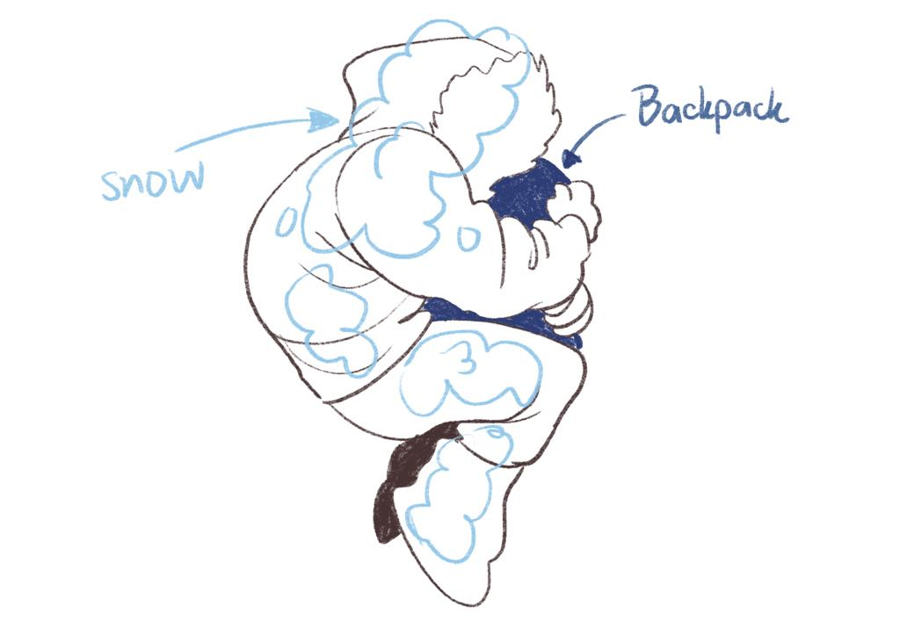
Figure 2: A sketch of the first look at the deceased mountaineer, created by the author

After finally regaining your composure, you gently lift his frozen hand out and look into his backpack hoping to learn about his identity. Searching through the backpack’s contents, you pull out empty snack packages and a few remaining chocolate bars. Beneath them is a disheveled first-aid kit, whose bandages unraveled and painkillers all used. Your fingers then meet a neatly folded paper in an inner pocket, which unintentionally turns out to be a letter, handwritten:

“Brett, love,

I heard you decided to return to mount climbing, with that barely healed ankle? What a daredevil you are! Turning a deaf ear to even your parents’ advice, then mine must weigh a feather. Jokes aside, can’t wait to see your name titled “The First Conqueror of Mount Glaxierra”... what a flex huh? But please, please, please return if things get uncanny.

Call me when you’re back,
L.”

The warmth and happiness between the two strangers make you smile, but soon become a pitying frown as soon as the howling wind reminds you of the harsh truth. Realizing how personal you have gone, you rush the letter back to where it was and return to searching. Then, at the very bottom of the backpack, you sense something cold and sturdy. That unknown thing scares you for a second before you pull out a pair of ice axes.

“These may do.” unconscious you say to yourself holding the axes [Sanity bar starts decreasing]. Immediately, such thought gives you shivers, you drop the axes and look at both hands in disgust and disbelief , as if “when your own life is threatened, your sense of empathy is blunted by a terrible, selfish hunger for survival.” (Yann Martel, 2001)

“I’m not… I can’t do this.” Your voice breaks, but no one else is there to hear it. You clench your fists and grind your teeth as if the cold has not already devoured your skin. No matter how hard you try to look away, the tension presses harder on your nerves. The axes lie in front of you, intimidate you with their bleak presence as they offer the two nastiest choices: taking them with you means desecrating the dead, or rejecting them equals accepting futility and surrender.

A faraway look then comes to your eyes as you stare into the endless mist. The sky is getting darker and darker, time is running out so you must proceed. But how? The path ahead, whether upward or downward, demands a tool you no longer have. Still, you must proceed. You cannot stop now, not when you have come this far, not when Elisabeth’s dream depends on you. You glance at the axes again, the cold objects glint right back as a mockery of your indecision. “What would you think of me?” you wonder, but only the breezy wind howls in response.

"For Elisabeth" you murmur tremblingly with your eyes shut and your head facing the ground. Like a bandit in torment, the cold numbs your hand as soon as you grasp the axes regardless of the thick gloves in between. "I’m sorry" you whisper, unsure if the apology is meant for the stranger, for Elisabeth, or yourself.

You finally have the urge to take the axes, get back on your feet, and be ready to proceed with the ascension. However, as you quickly investigate the tool for a safety check, you find a small carving near the bottom of the axe handle saying: “X, Latrice”. [Sanity bar reaches the lowest state]
Immediately after the moment you recognize the name, in the obscure haze and bone-chilling cold, the spirit of the dead mountaineer appears behind you, lunging forward non-stop as if striving to seize you. Despite being given not a second to process the situation but rather a heart attack, you manage to dodge at the last second and strike it with the stuff you just picked up—though the impact still throws you to the ground. Gasping for breath, you scramble up, snatch the nearby climbing pole, and hurl yourself back into the fight. [Oxygen bar gradually decreases]
Despite your furious attacks, the creature’s vitality seems endless, forcing you to give it everything you’ve got. Sometimes it leaps at you with terrifying speed [Quick Time Event begins]. One wrong move, and it’s all over. Finally, you spot your chance and unleash a crushing blow, watching in relief as the Spirit of Dead appears to dissolve into thin air.
Exhausted, you exhale and drop the axes, but no sooner have you caught your breath than it reemerges from behind. It turns out that it had only been hidden away momentarily. This time, without a weapon in hand, you’re knocked down hard. The Spirit of Dead stares right into your eyes, and you feel a dark mist seep from your mouth and eyes, draining away your soul. Despair engulfs you. You see flashes of your wife—her warmth, and the promise you made to fulfill her dream. For a moment, you accept defeat.
Just then, another climbing axe slams into the Spirit of the Dead, sending it flying into a nearby rock wall. In the flickering light, You see two men—one is seemingly Asian, while the other, a friendly-looking European, extends his hand toward you. He is the one who delivered that strike to the Spirit of the Dead. A flood of questions races through your mind, but there’s no time to speak; the Spirit of Dead has already risen, forcing all three of you into another battle.
Working together, you close in on the creature, each delivering punishing blows. One man fights with methodical precision, carefully aiming each strike, while the European man's strike looks quite comical, and his face radiates a constant, lighthearted optimism. When the Spirit of the Dead lunges at you, the European man calls out in time to help you dodge, while the Asian man also offers helpful advice to make your attacks more effective. When The Spirit of Dead is close to losing, it tries one last time to escape, but this time you experienced it before. [Quick Time Event begins] You react instantly, seizing the moment to smash the creature’s head. With a final shriek, it collapses and gradually fades into the darkness, leaving behind only a suffocating sense of gloom—and a mountain of unanswered questions. [Quick Time Event ends] Gradually, your vision returns from the blur caused by the spirit’s attack. [Sanity bar increases]
"You alright there?" said the European man.
"Thanks for saving me," you reply while catching your breath. [Oxygen bar almost runs out]
The European guy glances at the gauge on your oxygen tank and exclaims, "Hey, you're almost out of oxygen!" You are startled, dropped to one knee, and pulled the tank down. “It’s really empty,” You mutter to yourself, “Must’ve been drained too fast during the fight.”
As you are thinking, the European guy also takes the tank off his shoulder. You watch as he pulls an oxygen transfer valve from his pocket, designed with one intake and one output. He looks at you, grins, and says, "Lucky for you, I just refilled my oxygen at a base camp nearby."
Before you could respond, he snatches your tank and attaches the transfer valve between the tanks. You watch as he first opens his full tank, letting the gas flow into the valve, then slowly twists yours open. The sharp hissing sound of the gas moving fills the air. After a while, he finishes the transfer, "There we go, enough air to keep going, huh?" [Oxygen bar is fully refilled]
Standing before you are two mountain climbers. One of them, the European man with a well-worn pack. “Be aware of the spirits of the dead,” he warns. “They’re said to be restless souls of those who lost their lives on this mountain. Acts of harm or looting their belongings show disrespect. That’s what stirs their rage.”
As the European climber speaks, the Asian climber moves closer to the lifeless body nearby. He kneels beside it, clasps his hands together in a prayer gesture, and bows his head deeply. The gesture speaks of solemnity and respect for the departed.
The European climber unslings the axe strapped to his pack. “You’ll need something for protection,” he says, offering it to you. “It’s always better to have something to defend yourself, even if you don’t end up needing it.”
It’s a beginner’s pack axe, less powerful than the one you looted from the corpse. Your gaze drifts back to the fallen climber. The item you took earlier feels heavier in your pack.
[A prompt appears] “Do you want to return the looted item to the spirit of the deceased?”
- Yes: You kneel beside the body and place the item back near it, muttering an apology under your breath. Following the climber’s earlier action, you bow deeply as a sign of respect. The air around you feels lighter, and you sense a subtle shift—as though the spirit’s anger has subsided. [Your morality is restored to its previous level]
- No: You kindly returned the European’s axe to him. Then, you tighten your grip on the axe of the spirit and turn away, justifying the theft as a necessity for survival. A faint chill runs down your spine, as though unseen eyes are watching. [Your morality remains low]
After giving out the decision, [a dialogue conversion appears] to be greetings of the mountain climbers.
You (glancing at the two mountain climbers): “Thanks again for saving me. Are you two climbing to the summit of this mountain too?”
The European climber: “We are. This mountain, Glaxierra, doesn’t forgive mistakes. We’ve formed a team to face it together.”
The Asian climber: “This place has mysteries—like that Spirit of the Dead we just encountered. Respect is crucial. For the mountain and those who’ve perished here.”
You (hesitate, your voice carrying the weight of your decision): “You’re both experts. I thought I could handle this mountain alone... Clearly, I was wrong.”
The Asian climber (nodding with understanding): “We’re not looking for a hero. Let’s team up—it’s safer that way.”
You (taking a deep breath): “Alright. I’m with you. Let’s do this together. I’m Edward.”
The European climber (offering a firm handshake): “Albrecht.”
The Asian climber (giving a slight nod): “Yamada.”

SEQUEL
The three of you adjust your gear and set off cautiously along the icy trail. Along the way, you suddenly halt and point to a partially frozen footprint. “This isn’t ours,” you mutter. Yamada examines it, his expression is grim. “It could be from another climber—or something else,” he replies.
As the wind shifts, Albrecht tightens his hood and looks back at you. “A fierce storm is brewing at higher elevations. We should find a safer place to set up camp and start a fire.”
That night, you gather around the fire, sharing stories about your past and what brought you here.

CHARACTER’S MOTIVATION
Edward Meier
Edward is on a journey to fulfill his late wife's final wish. Driven by love, he is willing to do whatever it takes to survive and see her wish come true. Consequently, he is prepared to face a mysterious creature, fully aware that he could lose his life at any moment; he refuses to flee or give up.

For ten minutes, Edward demonstrates gratitude and acknowledges the danger he was just rescued from. This reflects a polite, cooperative, and humble attitude of his. He values teamwork and understands the importance of forming alliances, which establishes a foundation of trust with his rescuers.

As an experienced mountain climber, Edward is a quick learner. However, one aspect that could alter his character is the temptation to loot or steal from the deceased or local mountain inhabitants.

Upon discovering the source of the attacks from the spirits of the dead, he can choose to obey the spirits or justify stealing, depending on the player's choice. This action is the beginning that influences Edwad’s morality level, as mentioned in Assignment 2 - Morality.

Dr. Albrecht Schwarz
Albrecht stands out as an expert mountain climber and professor. His academic background motivates him to understand the treacherous environment of Mount Glaxierra as much as possible before attempting to conquer it. He is well aware of the danger of Mount Glaxierra, so he is well-packed and well-prepared. His generosity is evident when he offers Edward his alternative axe, showing his belief in the importance of teamwork and mutual aid in life-threatening situations.
In addition to his cautious nature, Albrecht is pragmatic and courageous when faced with immediate danger. His decision to attack the spirit of the dead to protect Edward demonstrates his willingness to take decisive action when necessary. He does not let fear or superstition dictate his choices.
Yamada Takehiro
Yamada is an expert mountain climber from Japan. While studying at an international school, he remains connected to Japanese culture, particularly the important tradition of respecting others. Unlike Albert, who is pragmatic, Yamada embodies a softer approach; he refrains from intruding on and disrespecting the mountain's spiritual essence.
Yamada's gesture of bowing in silence and prayer reflects the act of bowing in Japan (Ojigi). It conveys reverence and humility, with the angle of inclination, duration, and number of bows depending partly on the intensity one wishes or needs to convey (Kanpai, 2020). These actions signify Yamada’s deep respect for life and death, highlighting his commitment to cultural values even in extreme circumstances.

INFLUENCE OF THE STORY ON PLAYERS
Our intention is to introduce and immerse you in a world where living conditions are harsh, resources are scarce and your morality is questioned. This 10-minute gameplay marks the first time you have ever encountered the deceased throughout the game, foreshadowing how extreme the journey ahead can be and you may as well perish from the merciless Mount Glaxierra.

Although the moral fluctuation is no longer a fixed event, we want you to experience the mental fight as Edward with his motivations, and as yourself with your own ideal and moral identity. While Edward climbs to honor his late wife, Elisabeth, you’re drawn into his mental and emotional battles, deciding how much you’re willing to sacrifice for survival. This encounter compels you to question: Would you desecrate a stranger’s remains for survival? Or prioritize moral principles even when it may cost your own life? These are not only Edward’s struggles but also reflections of your own.

The impact of this encounter can extend beyond the moment. As you continue Edward's journey and encounter more and more moral decisions, the weight of this past choice still lingers regardless.

“To what degree is each of us a great person?” (Tonia Bock, 2013). The answer is yours to decide.

REFERENCE LIST
- Creative Skills (2021) Oxygen Gas Transfer From One Cylinder To Another, YouTube, accessed 17 January 2025, https://www.youtube.com/watch?v=CN2hjwf7_g4.
- Dow J, Giesbrecht GG, Danzl DF, et al. (December 1, 2019) ‘Wilderness Medical Society Clinical Practice Guidelines for the Out-of-Hospital Evaluation and Treatment of Accidental Hypothermia: 2019 Update’, Wilderness & Environmental Medicine, 30(4) doi:10.1016/j.wem.2019.10.002
- Expert advice (n.d) How to Climb Ice, rei, accessed 11th January 2025. https://www.rei.com/learn/expert-advice/ice-climbing-waterfalls-alpine-walls.html\
- Jordan Snobelen (2022) ‘The stoke was pretty high’: adaptive ice climbing in the Elora Gorge, Wellington advertiser, accessed January 11th 2025. https://www.wellingtonadvertiser.com/the-stoke-was-pretty-high-adaptive-ice-climbing-in-the-elora-gorge/
- Kanpai (2020) Japanese bowing etiquette and its meanings, Kanpai Japan, accessed 16th January 2025. https://www.kanpai-japan.com/japan-lifestyle/japanese-bowing-etiquette-meanings.
- Larksuite (September 29th, 2024) Quick Time Event (QTE), accessed 15 January 2025. https://www.larksuite.com/en_us/topics/gaming-glossary/quick-time-event-qte.
- Martel Y. (2001) Life of Pi: A Novel, New York: Harcourt.
- Quick Time Events, (n.d) God of War Fandom Wiki, accessed 15th January 2025. https://godofwar.fandom.com/wiki/Quick_Time_Events.
- Tonia Bock (2013) ‘Are You a Good Person? The Notion of Moral Identity’, Newsroom - University of St.Thomas, accessed January 13th 2025. https://news.stthomas.edu/publication-article/are-you-a-good-person-the-notion-of-moral-identity/

With signs of a too stiff chest for CPR and airway obstructed by snow, the mountaineer is pronounced death, therefore, do not resuscitate (Dow J, Giesbrecht GG, Danzl DF, et al. 2019)
Although having experienced mountaineering with your wife before, this is the first time you have ever seen a dead body or taken things that are not yours, let alone stolen from the deceased. Therefore, the guilt and disturbance leave you directionless for a great while.
You recognize the name from the letter found in the mountaineer’s backpack. Whatever Latrice is to Brett, she seems to be a very special one to him. Along with the fact that these axes are carved with custom notes, emphasizing how dearing the two’s relationship is and how meaningful this gift is to the dead mountaineer, makes your guilt and insanity peak.
Quick Time Event (QTE) (Larksuite, 2024) is a popular mechanic in action games which we took inspiration particularly from the series God of War. It demands split-second reactions where players interact with in-game cutscenes and influence their outcome (success or failure). Here are some functions of QTE: - Enhanced Responsiveness: It makes events feel more dynamic and interactive, allowing players to engage directly with cutscenes. - Increased Tension: QTE sequences heighten the sense of urgency, making pivotal moments more thrilling. - Immersion: By requiring real-time reactions, these events simulate the character's reflex-driven actions, creating a more immersive experience for players.

